Project Proposal

# Introduction

**Project Overview**

This project is a full-fledged e-commerce application designed to provide a seamless online shopping experience for users. It features an intuitive user interface and robust backend functionality to manage product browsing, shopping cart, orders, and user accounts. The system supports advanced e-commerce functionalities such as product variations, dynamic pricing, coupon codes, and order history.

**Objectives**

* To enable users to browse and search products efficiently.
* To provide a smooth shopping cart and checkout experience.
* To allow users to view and manage their order history and profile information.
* To implement secure authentication and authorization mechanisms.

# Functional Requirements

The key functional requirements of the system are:

**User Module**

* **User Registration and** Login: Secure authentication using email and password.
* **Profile Management:** Users can update their profile details, including email, name, and profile picture.
* **Authorization:** Access to cart and order functionalities is restricted to authenticated users.

**Product Module**

* **Product Browsing: Users can view products with details such as name, description, price, and images.**
* **Search Functionality: Users can search for products by keywords.**
* **Product Variations: Products can have variations such as size and color, with dynamic price adjustments.**

**Cart and Checkout Module**

* **Add to Cart:** Users can add products (with selected variations) to their cart.
* **Update Cart:** Users can modify quantities in the cart.
* **Coupon Codes:** Users can apply coupons for discounts, with validation for expiration and minimum order amount.
* **Checkout:** Users can place orders securely, with real-time cart validation.

**Order Management Module**

* **Order Creation:** Orders are created with a unique order number and stored in the database.
* **Order History:** Users can view their past orders with detailed item information.
* **Status Updates:** Orders have statuses such as "Pending," "Shipped," and "Delivered."

# Use-Case Diagram

A use-case diagram will visually represent the interactions between users and the system components. The main actors are Users and Admins. Key use cases include:

1. User registration and login.
2. Browsing products and adding to the cart.
3. Making order at checkout.
4. Viewing and managing orders.

## Figure

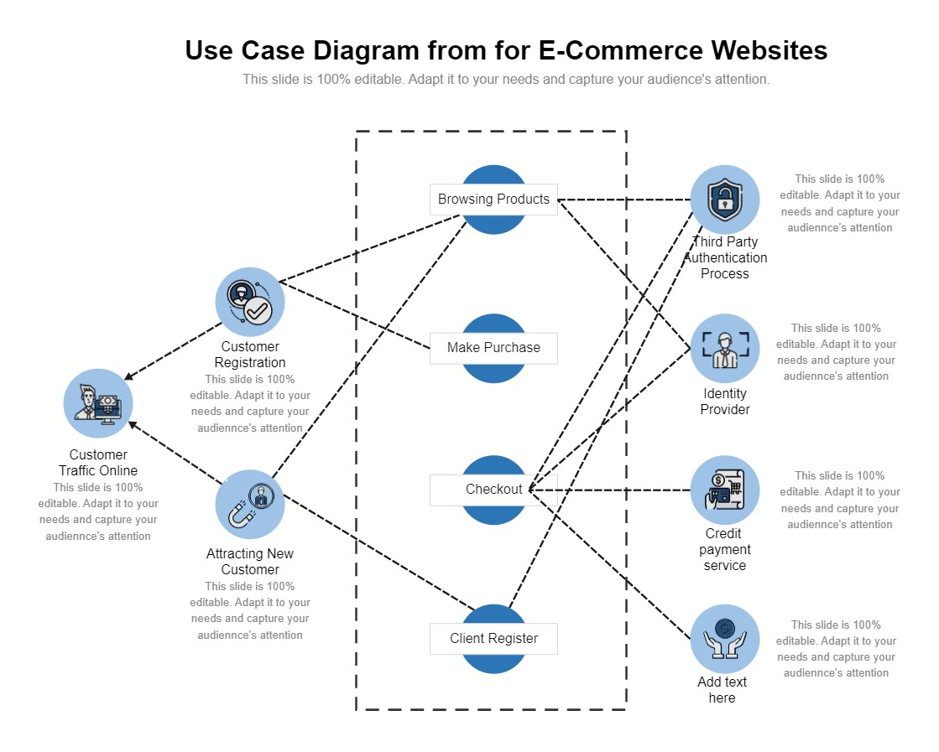

**Explanation:**

## • Actors

**Customer Traffic Online:** Represents users browsing the website for products or services.

**Customer Registration:** Refers to users creating accounts for personalized experiences and future purchases.

**Third-Party Authentication Process**: Involves external systems (e.g., Google, Facebook) for secure login or verification.

**Identity Provider:** Refers to systems managing user credentials during login or registration.

**Credit Payment Service:** Represents the payment gateway responsible for processing transactions.

**Attracting New Customers:** Implies marketing or strategies to bring new users to the platform.

## • Use Cases

**Browsing Products:**

Customers can search, filter, and explore the product catalog.

**Client Register:**

Customers can create accounts to enable personalized services and track orders.

**Make Purchase:**

Customers add items to their cart and proceed to complete the transaction.

**Checkout:**

Customers confirm orders, enter details, and finalize purchases.

## • Interactions

Customers interact with all components, such as browsing, registering, and purchasing.

Third-party authentication and identity providers streamline the login/registration process.

The credit payment service ensures secure transactions during checkout.

This diagram effectively highlights the interactions between system components and external services to ensure seamless e-commerce operations.

# Database Design

The database will have four primary models:

## Users Table

|  |  |  |
| --- | --- | --- |
| **Field** | **Type** | **Description** |
| id | Integer (PK) | Unique user identifier. |
| email | String | User's email address. |
| password | String | Hashed password. |

**Profile Table**

|  |  |  |
| --- | --- | --- |
| Field | Type | Description |
| id | Integer (PK) | Unique profile UID. |
| user_id | Integer (FK) | Associated user ID. |
| first_name | String | User's first name. |
| last_name | String | User's last name. |
| profile_image | String | Profile picture URL. |

**Category Table**

|  |  |  |
| --- | --- | --- |
| Field | Type | Description |
| id | Integer (PK) | Unique UID. |
| Category_name | string | Name of category |
| slug | String | Slug for name |
| category_image | String | Image URL |

**ColorVariant Table**

|  |  |  |
| --- | --- | --- |
| Field | Type | Description |
| id | Integer (PK) | Unique UID. |
| color_name | string | Name of Color |
| slug | String | Slug for name |
| Price | Integer | Price difference |

**SizeVariant Table**

|  |  |  |
| --- | --- | --- |
| Field | Type | Description |
| id | Integer (PK) | Unique UID. |
| Size_name | string | Name of Size |
| slug | String | Slug for name |
| Price | Integer | Price difference |

**Product Table**

|  |  |  |
| --- | --- | --- |
| Field | Type | Description |
| id | Integer (PK) | Unique UID. |
| Product_name | string | Name of Product |
| Category | Integer (FK) | Associated Category ID |
| Price | Integer | Price |
| Modal_number | String | Model number for product |
| Description | TextField | Description for product |
| Color_variant | Integer (FK) | Associated Color ID |
| Size_variant | Integer (FK) | Associated Size ID |

**Product Image Table**

|  |  |  |
| --- | --- | --- |
| Field | Type | Description |
| id | Integer (PK) | Unique UID. |
| Product | Integer (FK) | Associated Product ID |
| Image | Image Field | Image Path |
| Price | Integer | Price |

**Coupon Table**

|  |  |  |
| --- | --- | --- |
| Field | Type | Description |
| id | Integer (PK) | Unique UID. |
| Coupon_code | String | Code for discount |
| Is_expired | Boolean | True or False |
| Discount_price | Integer | Price |

**Cart Table**

|  |  |  |
| --- | --- | --- |
| Field | Type | Description |
| id | Integer (PK) | Unique UID. |
| User | Integer (FK) | Associated User ID |
| Coupon | Integer (FK) | Associated Coupon ID |
| is_paid | Boolean | True or False |

**CartItem Table**

|  |  |  |
| --- | --- | --- |
| Field | Type | Description |
| id | Integer (PK) | Unique UID. |
| Cart | Integer (FK) | Associated Cart ID |
| Product | Integer (FK) | Associated Product ID |
| Quantity | Integer | Quantity of cart product |
| ColorVariant | Integer (FK) | Associated Color ID |
| SizeVariant | Integer (FK) | Associated Size ID |

**Order Table**

|  |  |  |
| --- | --- | --- |
| Field | Type | Description |
| id | Integer (PK) | Unique UID. |
| User | Integer (FK) | Associated User ID |
| Cart | Integer (FK) | Associated Cart ID |
| OrderDate | DateTime | Store Order Date |
| status | String | Quantity of cart product |
| First_Name | String | First Name of customer |
| Last_Name | String | Last Nameof customer |
| Email | String | Email ID of customer |
| Phone | String | Phone of customer |
| Address | String | Address of delivery place |
| State | String | State of delivery place |
| City | String | City of delivery place |
| Payment_Method | String | Payment Method |
| Total_Price | Integer | Total order price after discount |
| CartItem | Integer | All cart items in user cart |

### **Entity Relationship Diagram (ERD)**

* **Users** → **Profile** (1-to-1 relationship)
* **Users** → **Cart** (1-to-many relationship)
* **Users** → **Order** (1-to-many relationship)
* **Cart** → **CartItem** (1-to-many relationship)
* **Product** → **CartItem** (1-to-many relationship)
* **Product** → **Product Image** (1-to-many relationship)
* **Product** → **ColorVariant** and **SizeVariant** (many-to-1 relationship)
* **Product** → **Category** (many-to-1 relationship)
* **Order** → **Cart** (1-to-1 relationship)
* **Cart** → **Coupon** (many-to-1 relationship)